1. List the available shells in your system.

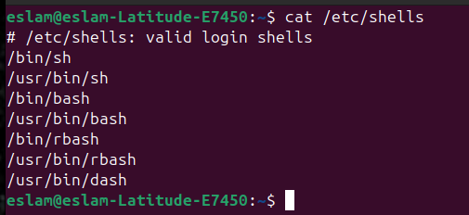

2. List the environment variables in your current shell.



3. List all of the environment variables for the bash shell.



4. What are the commands that list the values of all the variables?

Env

printenv

set

5. What are the commands that list the value of a specific variable?

echo

6. Display your current shell.



7. State the initialization files of: sh, ksh, csh, bash.

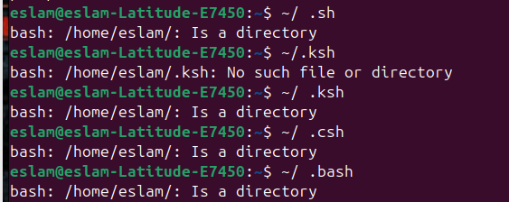

8. Edit in your profile to display date at login and change your prompt permanently.





9. Execute the following command : echo \ then press enter Notice the prompt what is that and how can you change it.

It is a Secondary Prompt.





10.Create a Bash shell alias named ls for the “ls –l” command

